

|  |
| --- |
|  |
| Ministry of Tourism and Antiques |
| |  |  |  | | --- | --- | --- | | Saba Hatamleh | 10/19/20 | Web Development |   2 |

Supervised by:

Dr. Jalal Kiswani

Dr. William Smairat

Ms. Jacquelyn Brown

Up-Skilling Project

# Table of Contents

Table of Contents 2

Abstract 3

Introduction 3

Project Details 4

Technology 4

•Software applications 4

Development 5

Services: 6

Conclusion 7

# Abstract

This website is aimed to help the users to easily reach the information about the ministry. The website would provide three E-services which help the users to reduce time and effort that are consumed by the person when s/he goes from one place to another to do her/his transactions.

The website is a responsive website that means it can adapt to any device screen size whether it is desktop, a laptop, a tablet, or a mobile phone. The website has good layout which suites the tourism sector.

# Introduction

According to the argent need of having an attractive website of such an important gate of Tourism in Jordan; the web site of Ministry of Tourism has been designed to be helpful, attractive and easy to use. At the same time that it provides the most needed services launching from the believe of web services and its need recently. It also provides a variety of information to provide the website visitors with the important information in a reachable and informative way. The web site also covers the latest news Journalism file of the Mistry. Also, it contains general information about the Ministry such as the minster word, organizational chart, compensations, regulations, and ministry projects and beds.

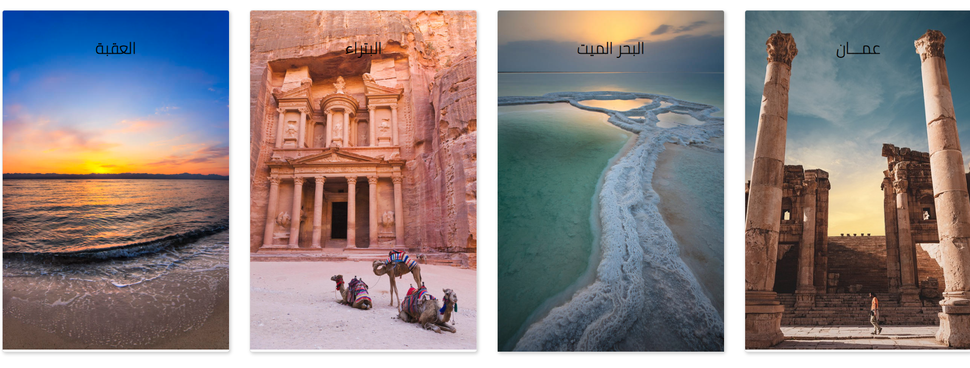

# Project Details

### 

### Technology

### •Software applications

1. Visual Studio

2. Draw.io

3. GitHub

4. Dropbox

5.MySQL Workbench

6. MS Applications (Word, Power Point, Team)

7. Adobe XD

## Development

Technology used in development:

HTML:  stands for Hyper Text Markup Language. HTML is the standard markup language for creating Web pages. HTML describes the structure of a Web page.

CSS: Cascading Style Sheets is a style sheet language used for describing the presentation of a document written in a markup language such as HTML. CSS is a cornerstone technology of the World Wide Web, alongside HTML and JavaScript.

Java script: JavaScript, often abbreviated as JS, is a programming language that conforms to the ECMAScript specification. JavaScript is high-level, often just-in-time compiled, and multi-paradigm. It has curly-bracket syntax, dynamic typing, prototype-based object-orientation, and first-class functions.

Bootstrap: is a free and open-source CSS framework directed at responsive, mobile-first front-end web development. It contains CSS- and JavaScript-based design templates for typography, forms, buttons, navigation, and other interface components.

PHP: is a general-purpose scripting language especially suited to web development but it now stands for the recursive initialism.

MySQL: is an open-source relational database management system. Its name is a combination of "My", the name of co-founder Michael Widenius's daughter, and "SQL", the abbreviation for Structured Query Language.

## Services:

The website provides three E-services which are:

1-license form: a form that provides the ability to renew a guide license by just filling all required fields.

2-Submit a compliant: a form that provides the ability to submit a compliant by filling all the required fields.

3-Apply for training program: a form that provides the ability to apply for training.

The website provides a rich information for the visitor that helps him to know more about the Ministry of Tourism and tourism sites in Jordan such as:

* Minster’s word.
* Organizational chart.
* Conventions.
* Regulations.
* Vision
* National strategies
* Ministry projects
* Ministry beds
* Essential information about Jordan
* Where to stay and eat in Jordan
* Transition means in Jordan
* Destinations
* News and journalism files.

# Conclusion

After deep analyses and research of the needs of Ministry of Tourism website, I tried my best to come up with an attractive useful website that provides a rich information for the visitor that helps him to know more about the Ministry of Tourism and tourism sites in Jordan plus the facilities and hotels in this vital sector. The web site also covers the latest news Journalism file of the Mistry. Also, it contains general information about the Ministry such as the minster word, organizational chart, compensations, regulations, and ministry projects and beds.